Table of Contents

How to Build your list (1:00) 2

Previously Collected 2

Import from a Spreadsheet 2

Add Manually 3

New Subscriptions 4

Organizing Your List 4

Segmenting Your List 4

Tagging Your List 6

Single-Tag 6

Bulk Tag 8

Grouping a List 9

Creating a Template (22:00) 9

Creating a Campaign (26:00) 9

Steps of Creating Campaign 9

Designing your email 9

Scheduling your email 12

Reports 13

Buttons 13

Add to Calendar 13

# How to Build your list (1:00)

In this section you will learn how to Build and add onto lists within the MailChimp website. Segments and tags will also be briefly discussed.

## Previously Collected

There are two main ways of Building your list with previous collected data. This is mainly done by importing a list or manually entering the names.

### Import from a Spreadsheet

1. 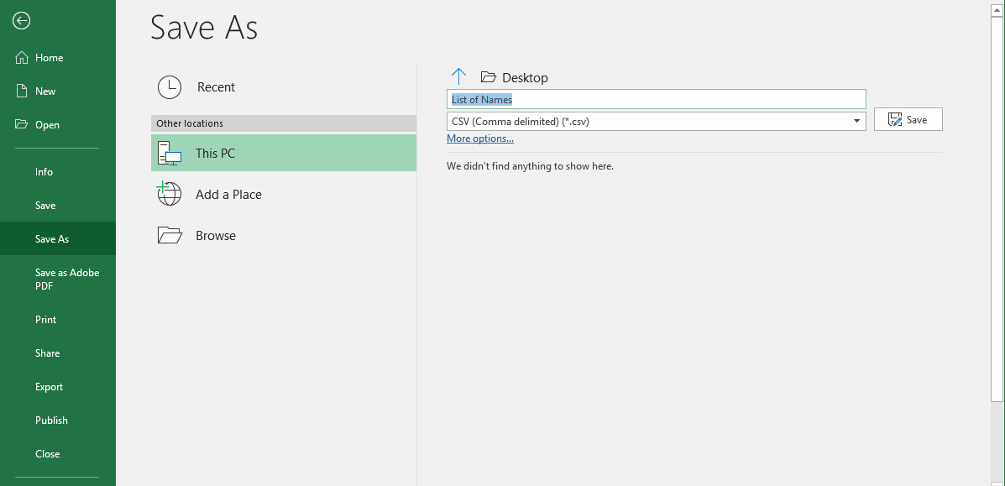Make sure the spreadsheet you are working from is in the right format (*.csv)
   1. To do this go to save as and make sure that the format (below the title) is on a CSV format.
2. 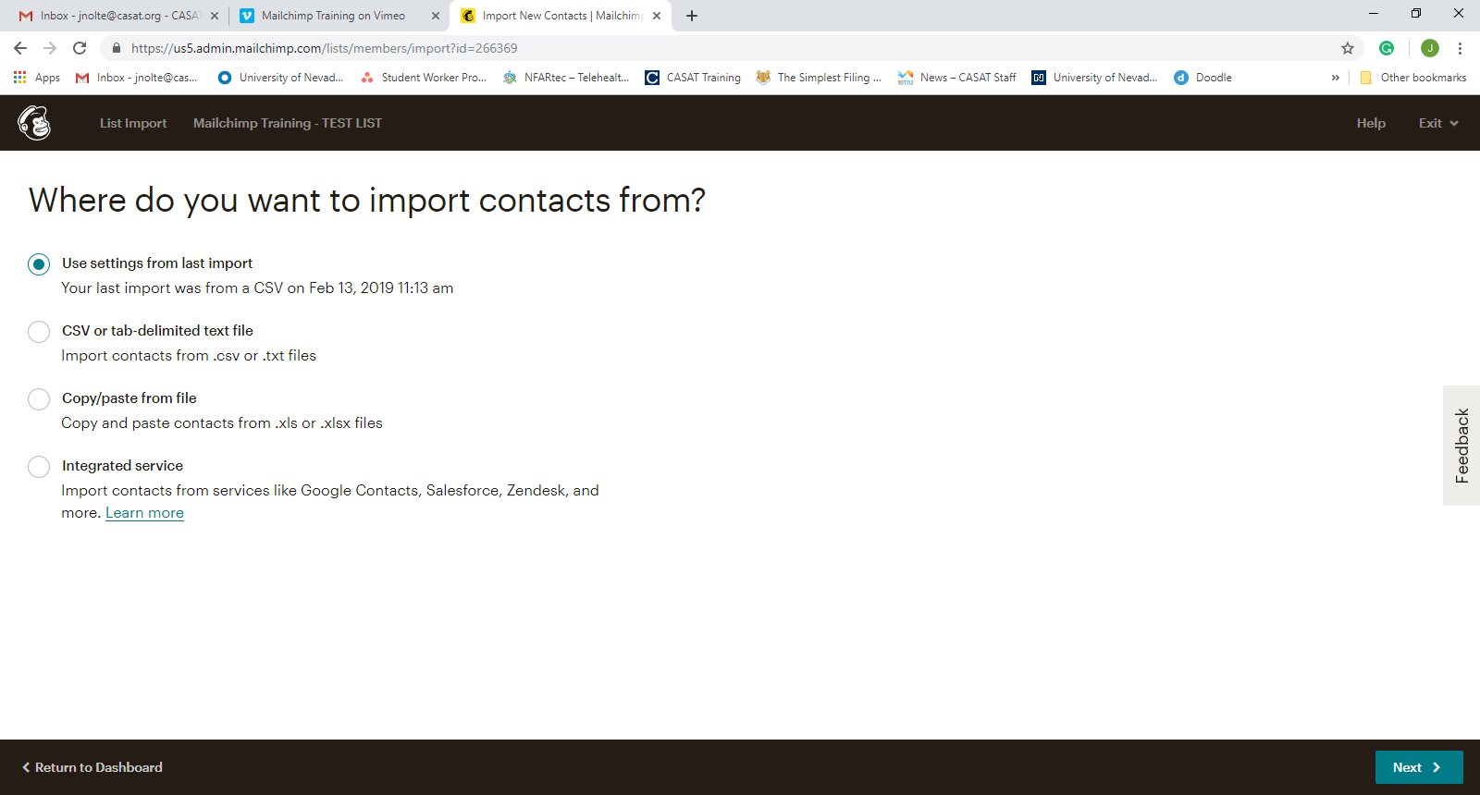Choose how you want to import the contacts
   1. Use settings from last import
      1. Use the last list that you used to upload onto the site
   2. CSV or tab-delimited text file (Most likely to use)
      1. Import a .csv file with a list of contact information
   3. Copy/Paste from file
      1. Copy and paste a list of names from an .xls or .xlsx file
   4. Integrated Service
      1. Import contacts from an outside service.

### Add Manually

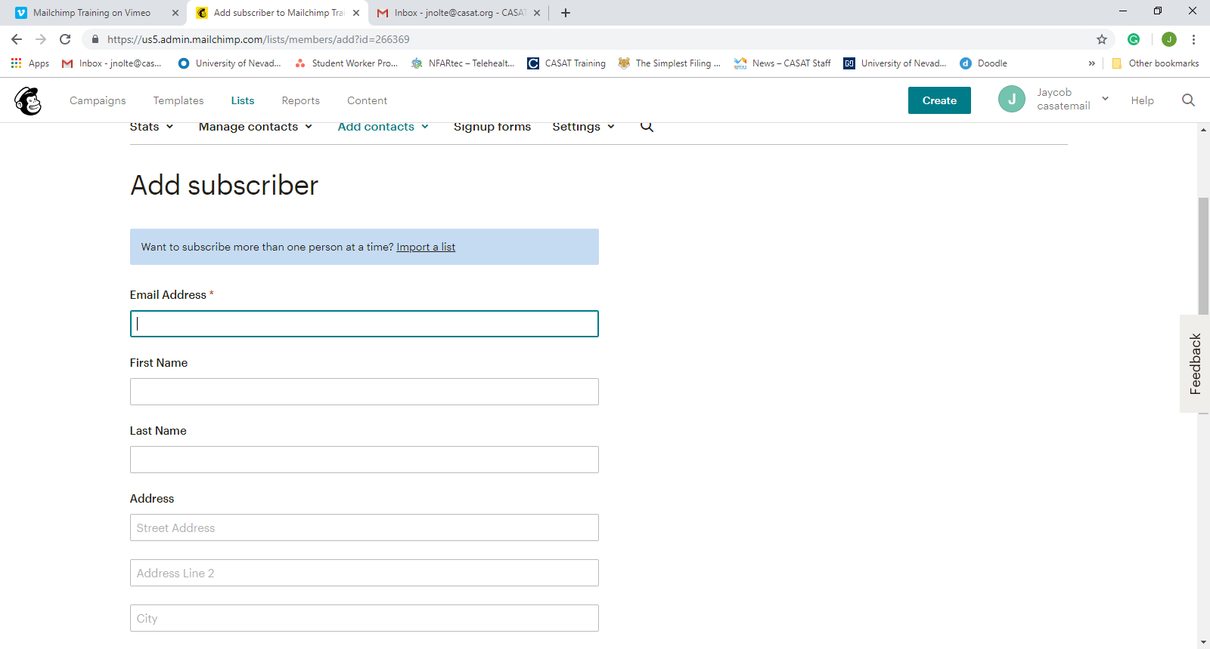

## New Subscriptions

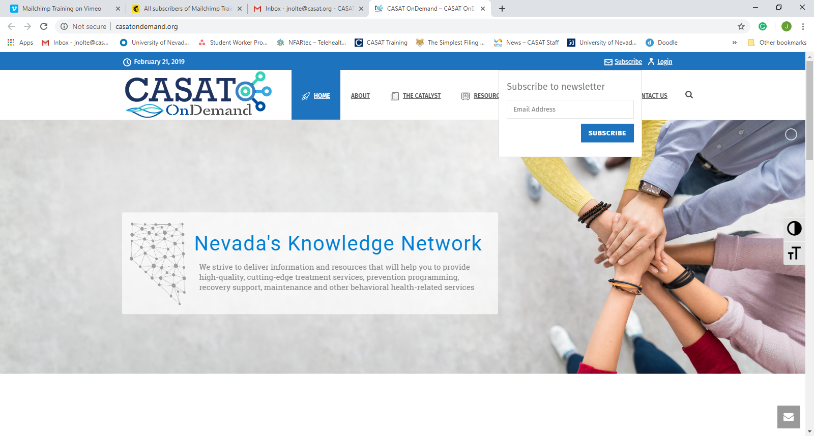

# Organizing Your List

There are Three Different ways in which you can organize your list.

* Segmenting
* Tagging
* Grouping

All three of these can be used to send specific campaigns to distinct populations.

Segmenting is used for when you already have a list and you want to sort by a data field that they filled out when signing up for the listserv.

Tagging is for internal use and lets the list creator tag people so that they can be further sorted. People can have as many tags as necessary. Tags do not have to correspond with any data that the participants listed but can be used to further separate them.

Grouping is for external use in that people choose to be put into groups. When creating a list, you can insert groups into your sign up form and have options for people to hear about specific populations/content and they choose for themselves and are filed as necessary.

## Segmenting Your List

1. Go into your list
2. Under ‘Manage Contacts’ drop down click the ‘Segments’ option
3. Click the ‘Create Segment’ button on the top right of the page

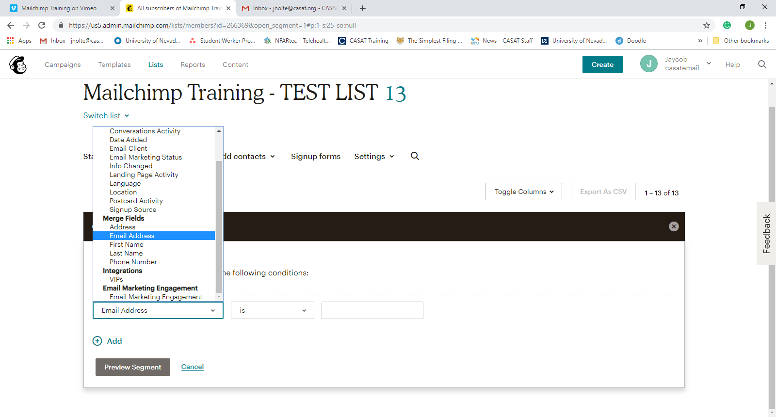

1. Choose the info that you would like to segment the list by.
   1. You usually want to scroll down to the section that says “Merge fields” because these are the fields that are available in your list.
2. Type what you want to segment them by in the third box
   1. Ex. If you want to sort them by state change the first box to ‘State’ (it has to be a field in your list) and then type in the state you want to sort them by. So, if you want a Nevada list put Nevada in the third box.
3. Click Preview Segment and if the segment contains the people that you want to have click the save segment option.

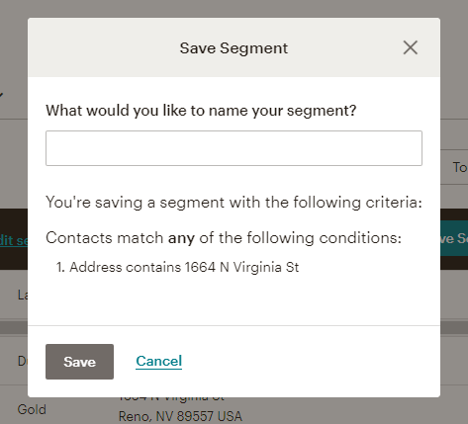

1. After clicking save segment a dialogue box appears and asks what you would like to name the segment.
2. Name the segment and click save.

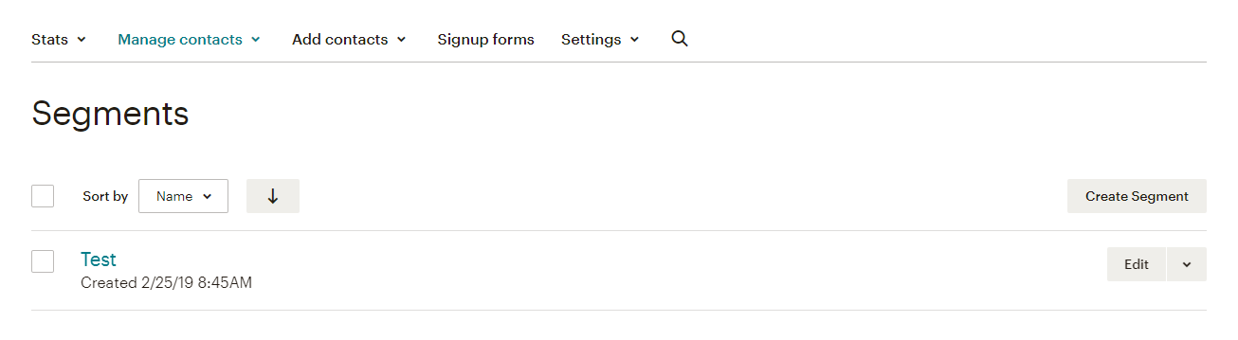

1. The segment is now in your segment list and can be used to send specific groups of people emails without emailing the entire list.

## Tagging Your List

Tags are used mainly to structure people within the list into many different categories. Tags can be created when you are segmenting a list, individually, or in bulk-tags. People can have more than one tag on their user at a time. This helps sort people into more than one field in case they want to be included in certain email threads.

The hard part about tags is that mostly they are internal use only so you do have to tag everyone that you would like in the tag. Bulk-tags are a way around this but need to be uploaded at the time you create a tag and not with an already created list.

### Single-Tag

1. Go to the “Tag” tab under the “Manage Contacts” drop down menu
2. 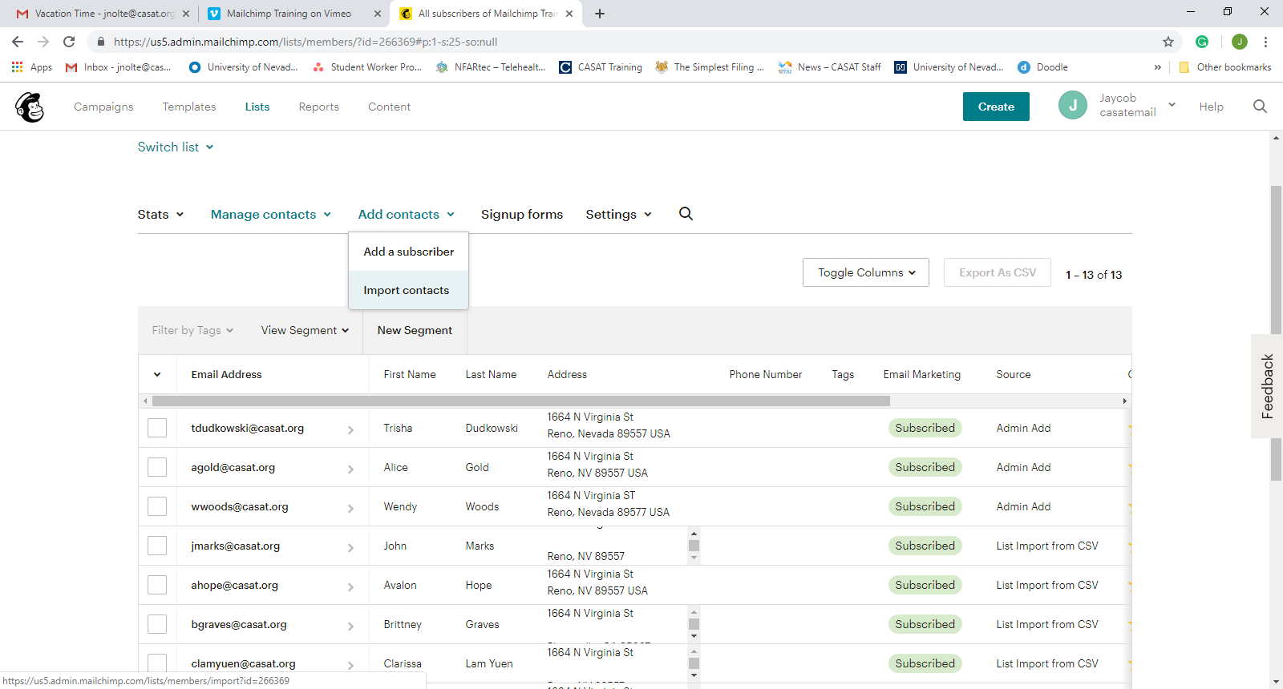Click create tag

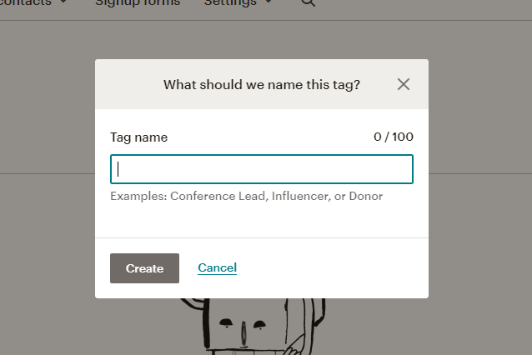

1. A dialogue box will appear, prompting you to enter a name for the tag that you will be creating.
2. 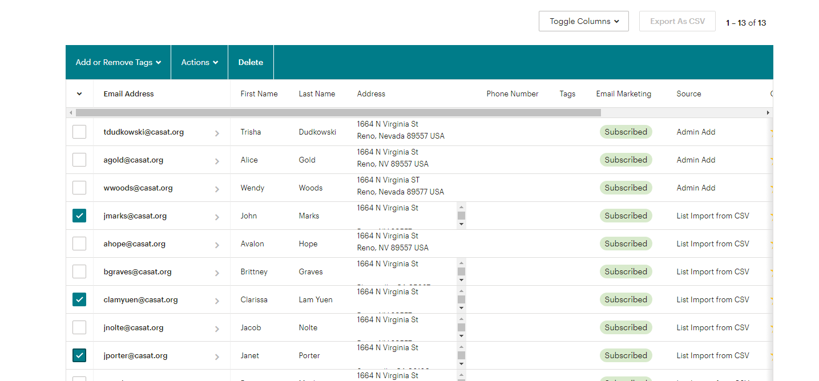Then you can go back into your list and add specific people to the tags.
3. Click the specific people that you want with this tag.
4. Hit the “Add or Remove Tags” button
5. 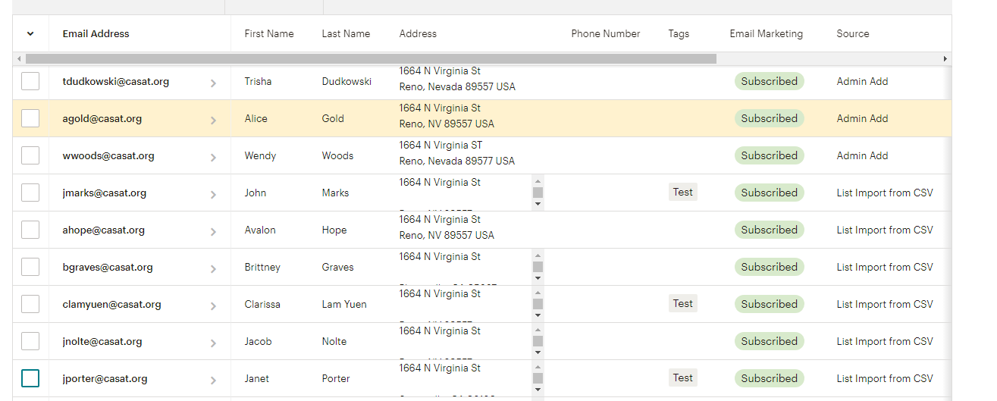The tag then appears in the tag column
6. If you go back into the Tag tab you can then send specific campaigns to people that you have tagged.

### Bulk Tag

This is used for importing a list and tagging every email on that list, so you do not have to do it later.

1. Start in the “tag” tab under the “Manage contacts” Drop-down
2. Hit the Button “Bulk Tag Contacts”
3. Name the list.
4. Upload a .csv file full of email addresses and other information that is necessary for the list that you are working on.
5. Hit save tag and the tag is created!

## Grouping a List

Groups are used in signup forms and allow people to choose to segment themselves.

1. To create go into the “Groups” tab under the “Manage contacts” drop-down
2. Hit the create groups button.
3. You can make it so that the people signing up for your list can select multiple options or one option
4. Refer to the Media team for help since they make most of the sign-up forms.

# Creating a Template (22:00)

Create a media request with what you want it to have.

# Creating a Campaign (26:00)

Campaigns are what MailChimp uses to describe emails sent out to the lists that you have created.

## Steps of Creating Campaign

1. Go to the “Campaigns” tab on the main MailChimp site.
2. Hit “Create Campaign” button to get started on creating the campaign.
3. Choose what kind of medium you want the campaign to be
   1. Email – an email message or update
   2. Ad – an advertisement for a website
   3. Landing page
   4. Postcard – printed postcards with information on them
   5. Signup form – A form to embed into your website for people to sign up for your email list
4. After you choose which medium to use it will ask you to name your campaign, and what type of email you want. Regular (from template), Automated (From template), Plain-text (just text email), A/B Test (Testing email)
5. Name your campaign so that you can recognize it later
6. Create Campaign

## Designing your email

1. Your email will then pop up as a draft and you fill out the four different segments
   1. To (Who you are sending your campaign to)
      1. In this section you add lists that you want to send your email to
      2. Once you choose a list a second tab will open and allow you to choose a specific tag or segment to further specialize the list
      3. “Personalize the “To” Field- this is a checkbox when determining who to “To” is. It adds merge tags to display your recipient’s name. For example, *|FNAME|* *|LNAME|* will show as "To: Bob Smith" instead of "To: bob@example.com." This is more personal and may help avoid spam filters.
   2. From (Who is sending this campaign)
      1. This gives you two sections a “Name” section and an “Email Address” section so that you are able to clearly show recipients who is sending this email.
   3. Subject (What’s the subject line for this campaign?)
      1. This section gives you two sections as well. “Subject” section allows you to give the email a special title and is able to include emojis as well.
      2. The second section is the “Preview text” section. It is what shows behind the title so that people can get a preview of the email before they even open it up. Emojis are also available for this section
   4. Content (Design the content for your email)
      1. This is the bread and butter section, and where the most time will probably be spent.
      2. When you click on “Design Email” it will take you to a section that has many different tabs with premade layouts. This is also where you can find the templates that you have made previously.
      3. There are five different tabs in this area, “Layouts” “Themes” “Saved Templates” “Campaigns” “Code your Own”
      4. “Saved Templates” is where all the templates that have been created by the media team are.
      5. 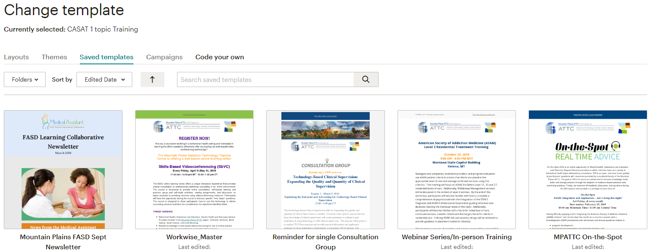From there you can search for the correct template that you would like to use for the basis of your email.
      6. Once you choose the template that you are going to be using you can make changes to it with the design tools.
      7. This can include anything from the content and design tabs.
         1. Content Tab
            1. Text- Add a simple text box
            2. Boxed Text- Add text with a border around it
            3. Divider- Visually separate your content with a dividing line
            4. Image- Insert an image into your campaign
            5. Image Group- Arrange a collection of images
            6. Image Card- Build a card with an image and caption
            7. Image + Caption- Add an image with a descriptive caption
            8. Social Share- Allow your audience to share the message on social media
            9. Social Follow- Promote your social media accounts
            10. Button- Create a prominent call to action (can be used to link to registration sites etc)
            11. Footer- Insert your contact information and required unsubscribe link
            12. Code- Use and insert your own HTML
            13. Video- Add a video
         2. Design Tab
            1. This allows you to better refine the details of your message with specific color designs and so on. This is best to be left to the media team and only changed if necessary.
2. When you are ready to send the email, it might be a good idea to send a test email.
3. 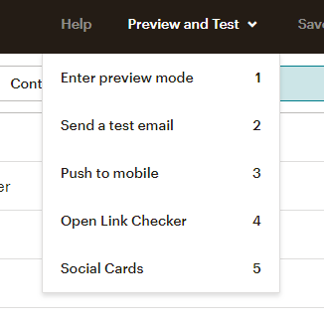To do this go to the preview and test tab while working on the template’s design.
4. There are five options here.
   1. Enter Preview Mode- Which allows you to see a glimpse of the email before you send it
   2. Send a Test Email- Which allows you to send the email to a select few and you can allow them to comment on it as well so that all of your team has input.
   3. Push to Mobile-
   4. Open link Checker- This allows you to make sure that all of the links used in the email are working properly.
   5. Social Cards- This
5. Once you are finished editing and are ready to send the email out hit the send button and a second dialogue box will appear prompting you to hit submit again and if you are really sure you want to send it then click send.
6. Your email is now complete!

## Scheduling your email

* + - 1. If you want to schedule your email to be sent out later, then before you send it click the schedule button located next to the send button.

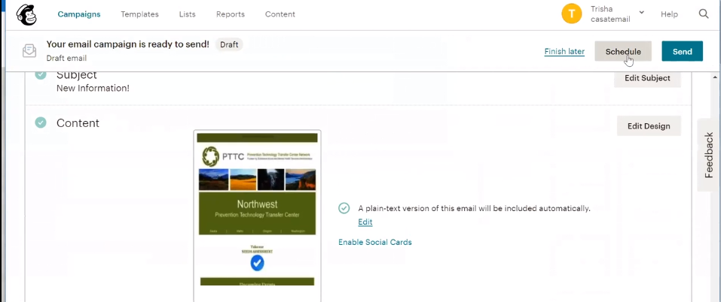

* + - 1. You can also send the email in batches if you do not want it to go out all at once.
      2. Once you have finished what you want in the scheduling options then hit schedule campaign and it will be sent out according to your preferences.

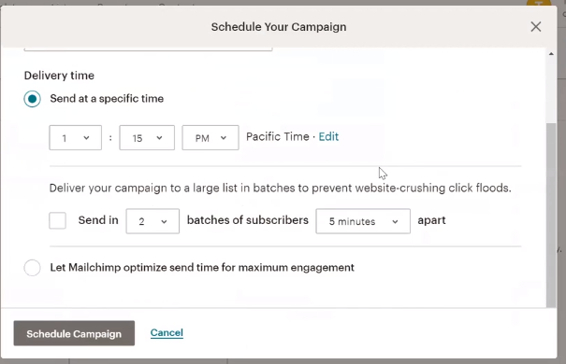

# Reports

1. This is a feature of mailchimp that allows you to look and see how well your surveys are doing.
2. On the front page it details comparison to the industry standard of email open rates and then also lets you know who clicked on the link within the email.

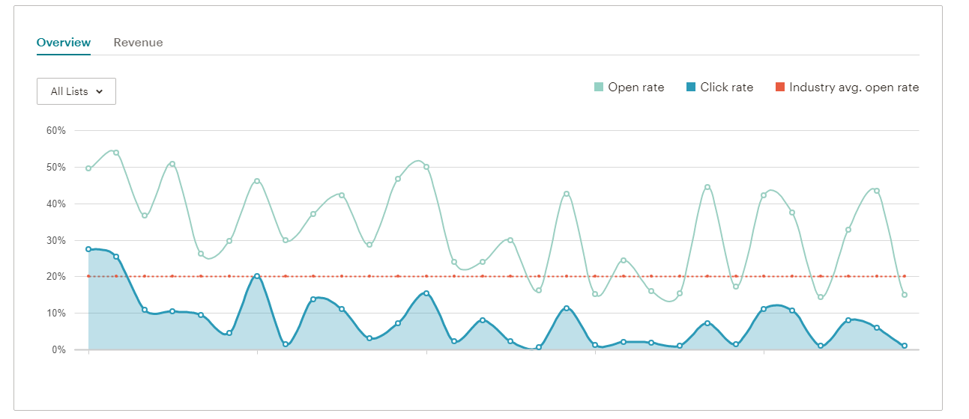

1. Each different campaign is given a Report which details various data about your campaigns including location of participants, 24-hour performance, Top links clicked, Subscribers with most opens, and social performance.
2. Reports can be downloaded individually or as a collective whole. If you do decide to download a report please make sure to only download the ones that you are working on.

# Buttons

## Add to Calendar

1. Submit a media request to add an “add to Calendar” button on your email